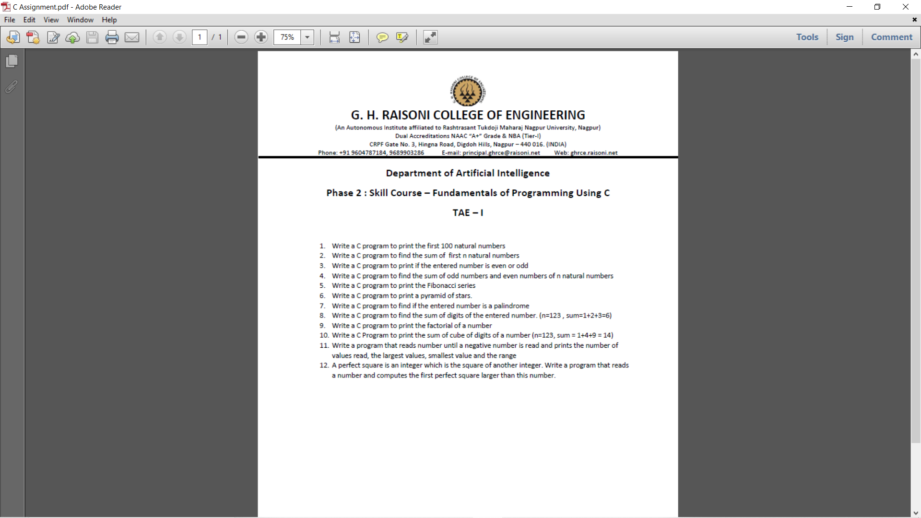

**Department of Artificial Intelligence**

**Phase 2 : Skill Course – Fundamentals of Programming Using C**

**TAE – I**

**Name-Gaurav Patil**

**Roll no.=54**

**Section=C**

**Submitted To: Prof. A. Thomas**

1) Write a C program to print the first 100 natural numbers

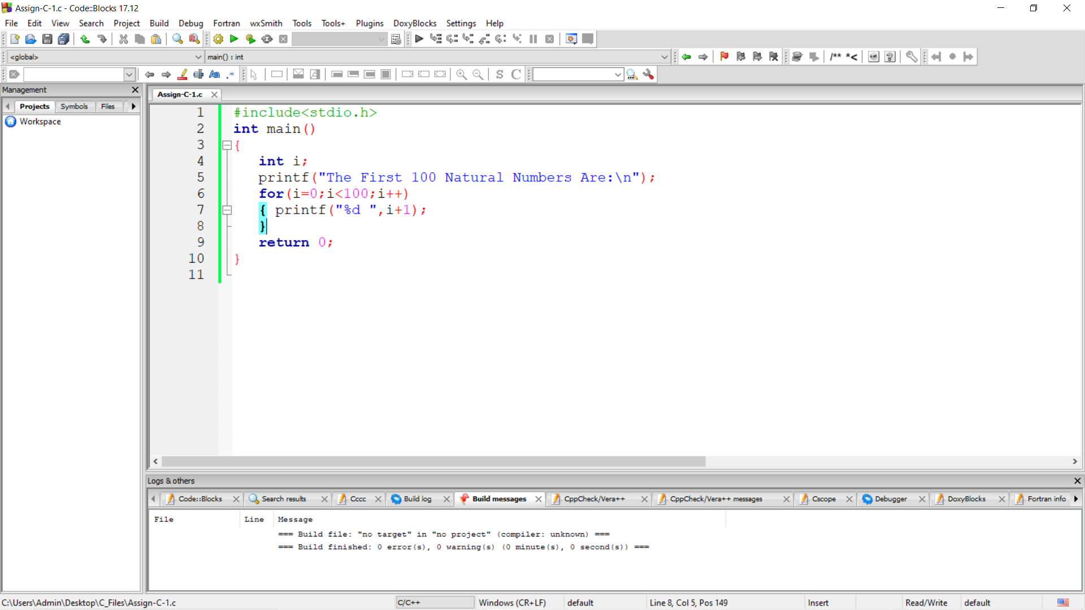

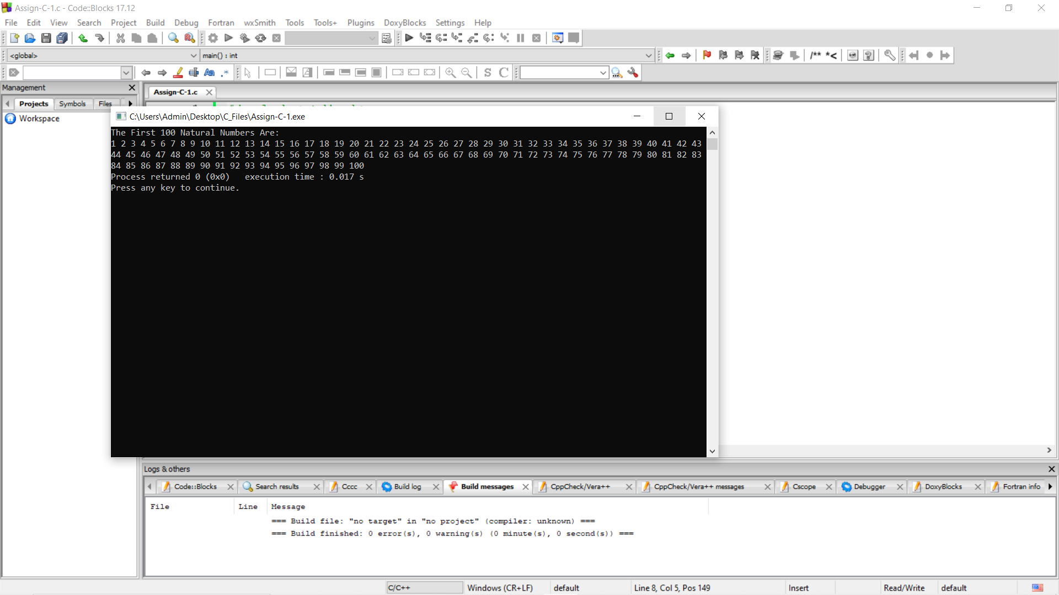

2) Write a C program to find the sum of first n natural numbers

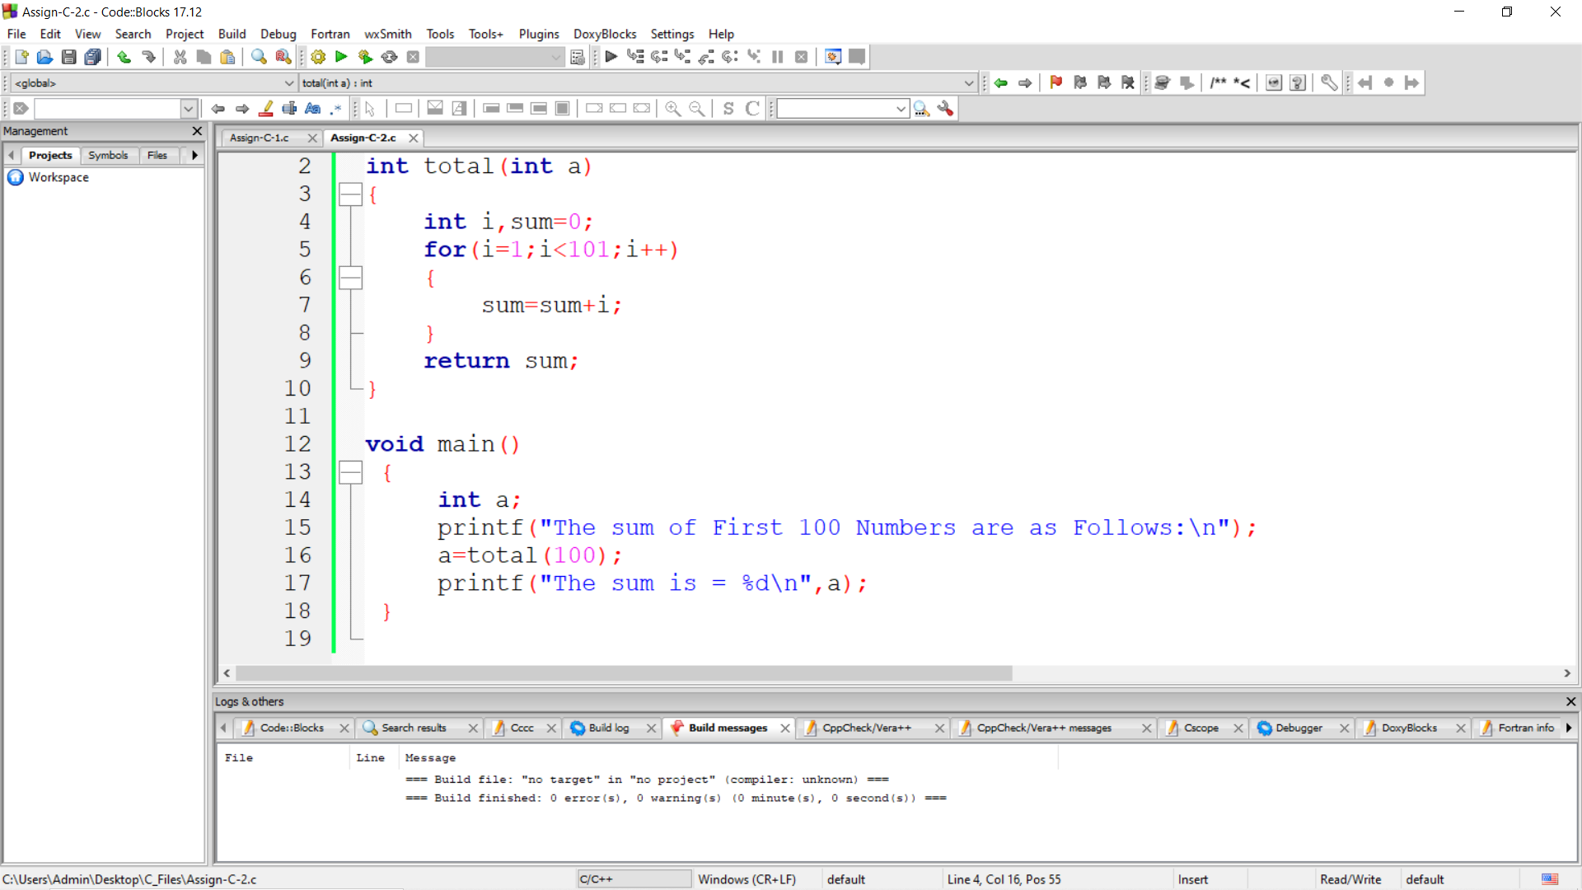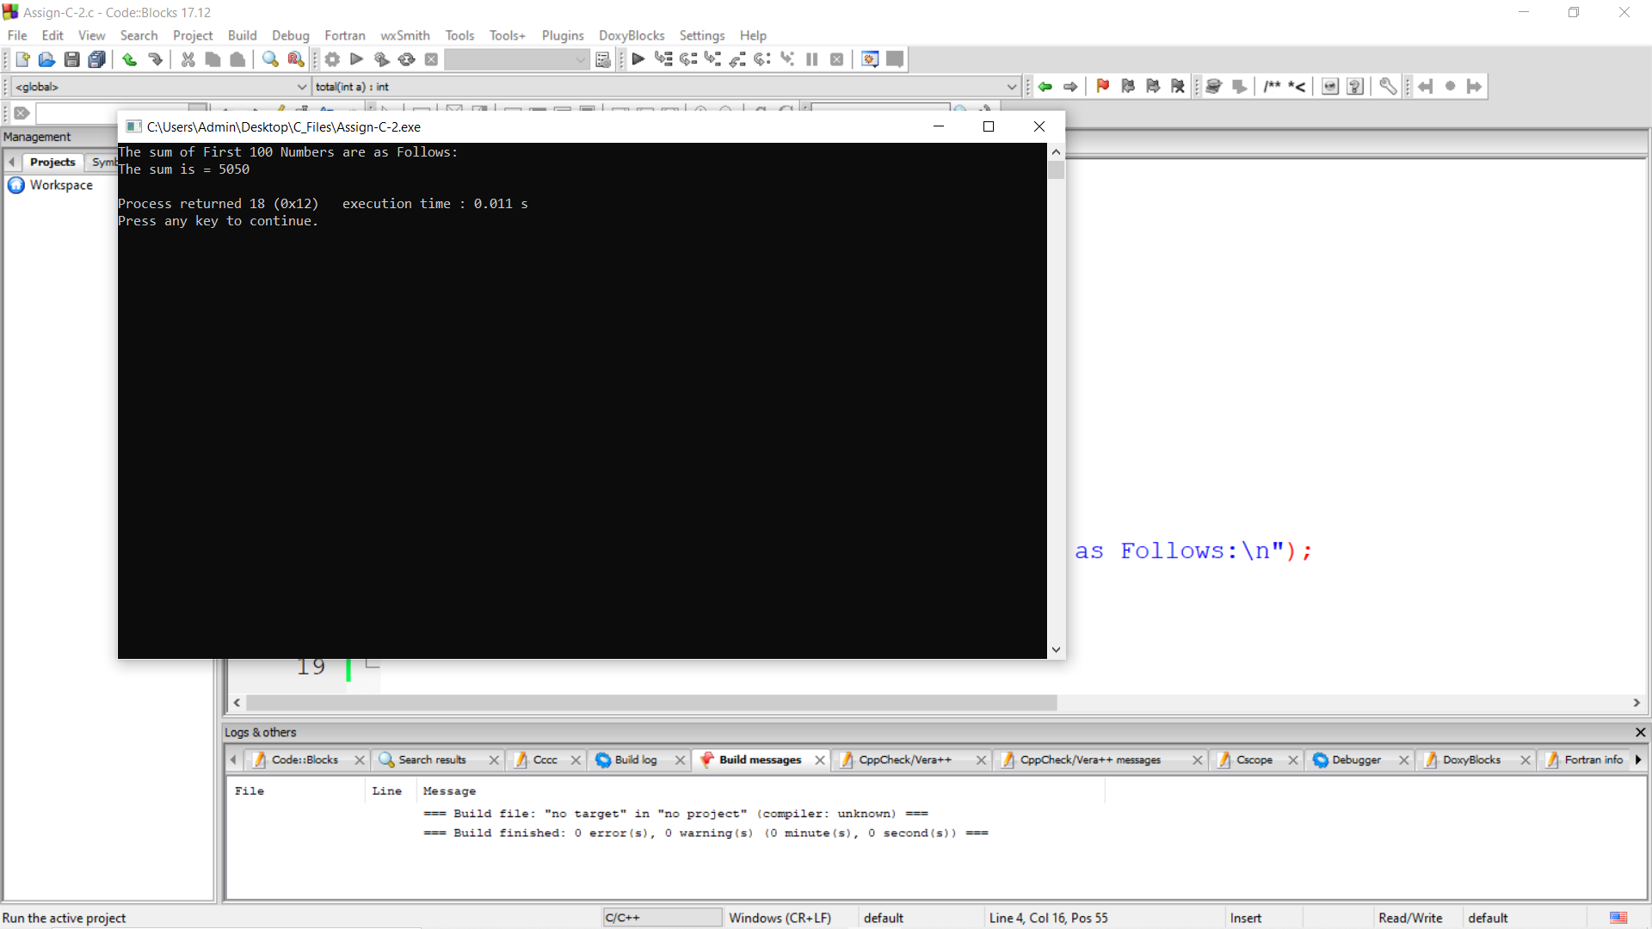

3) Write a C program to print if the entered number is even or odd 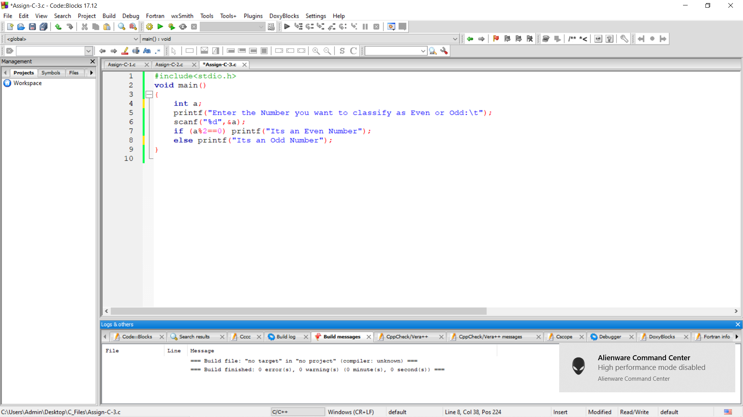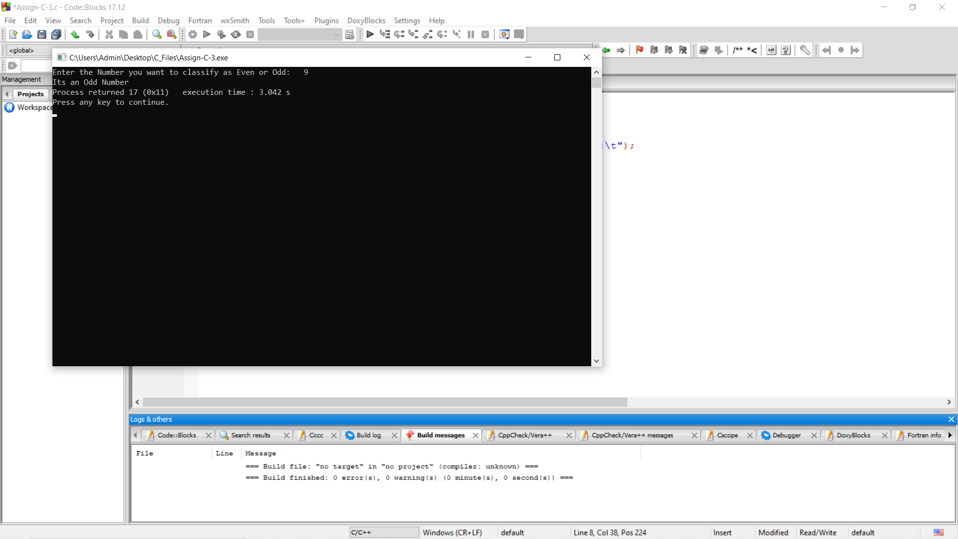

4) Write a C program to find the sum of odd numbers and even numbers of n natural numbers

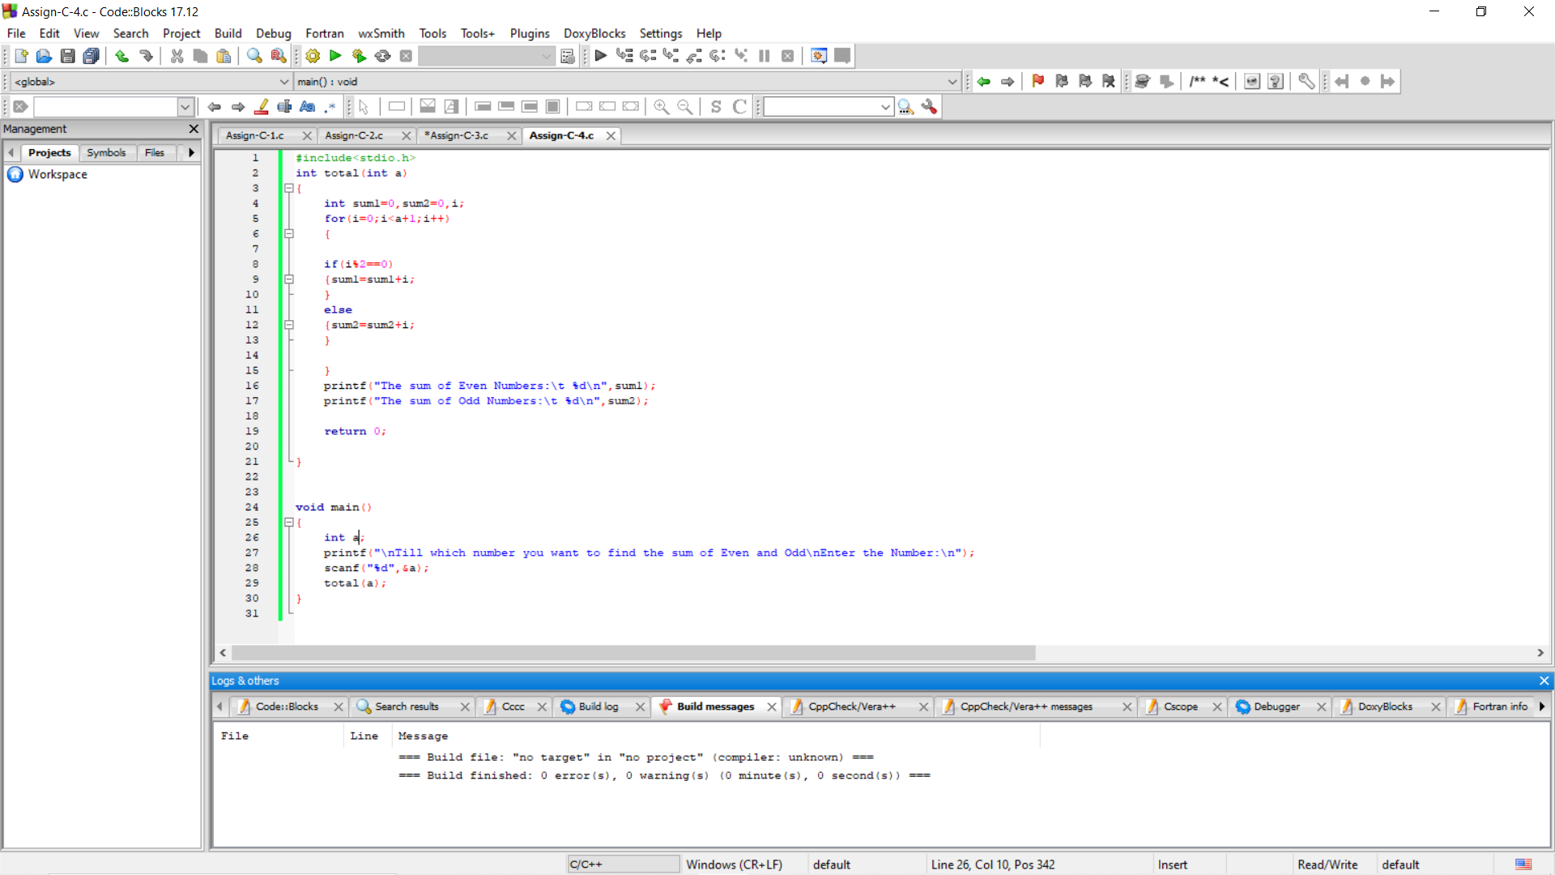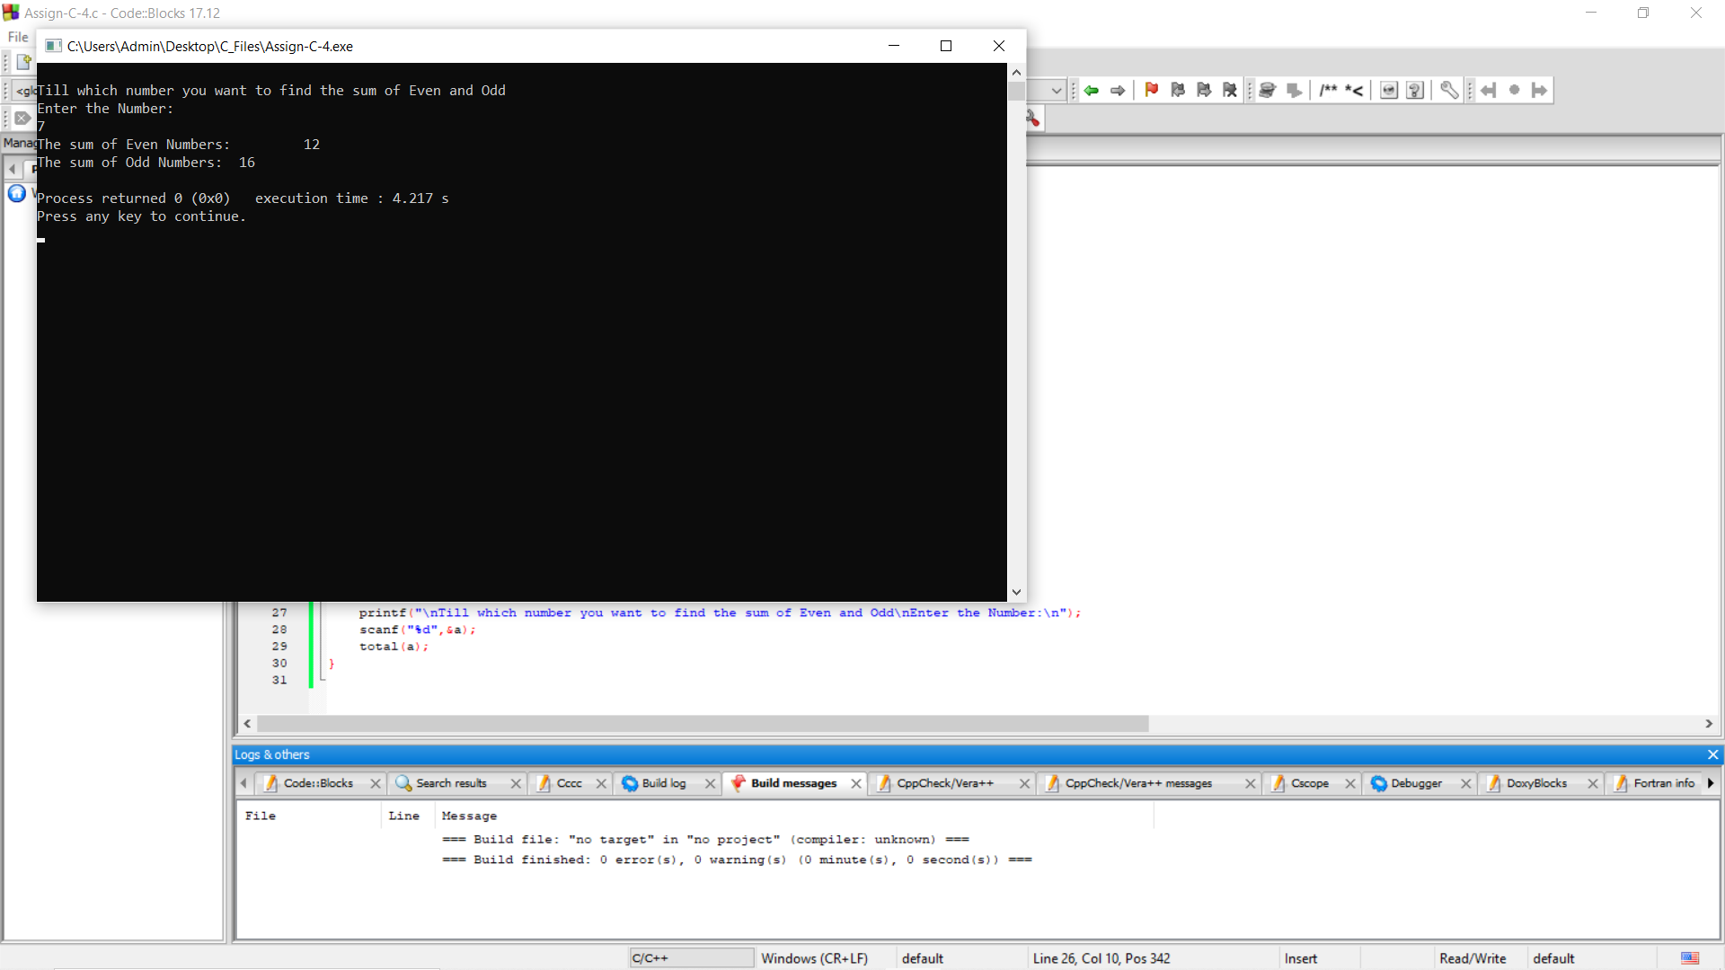

5) Write a C program to print the Fibonacci

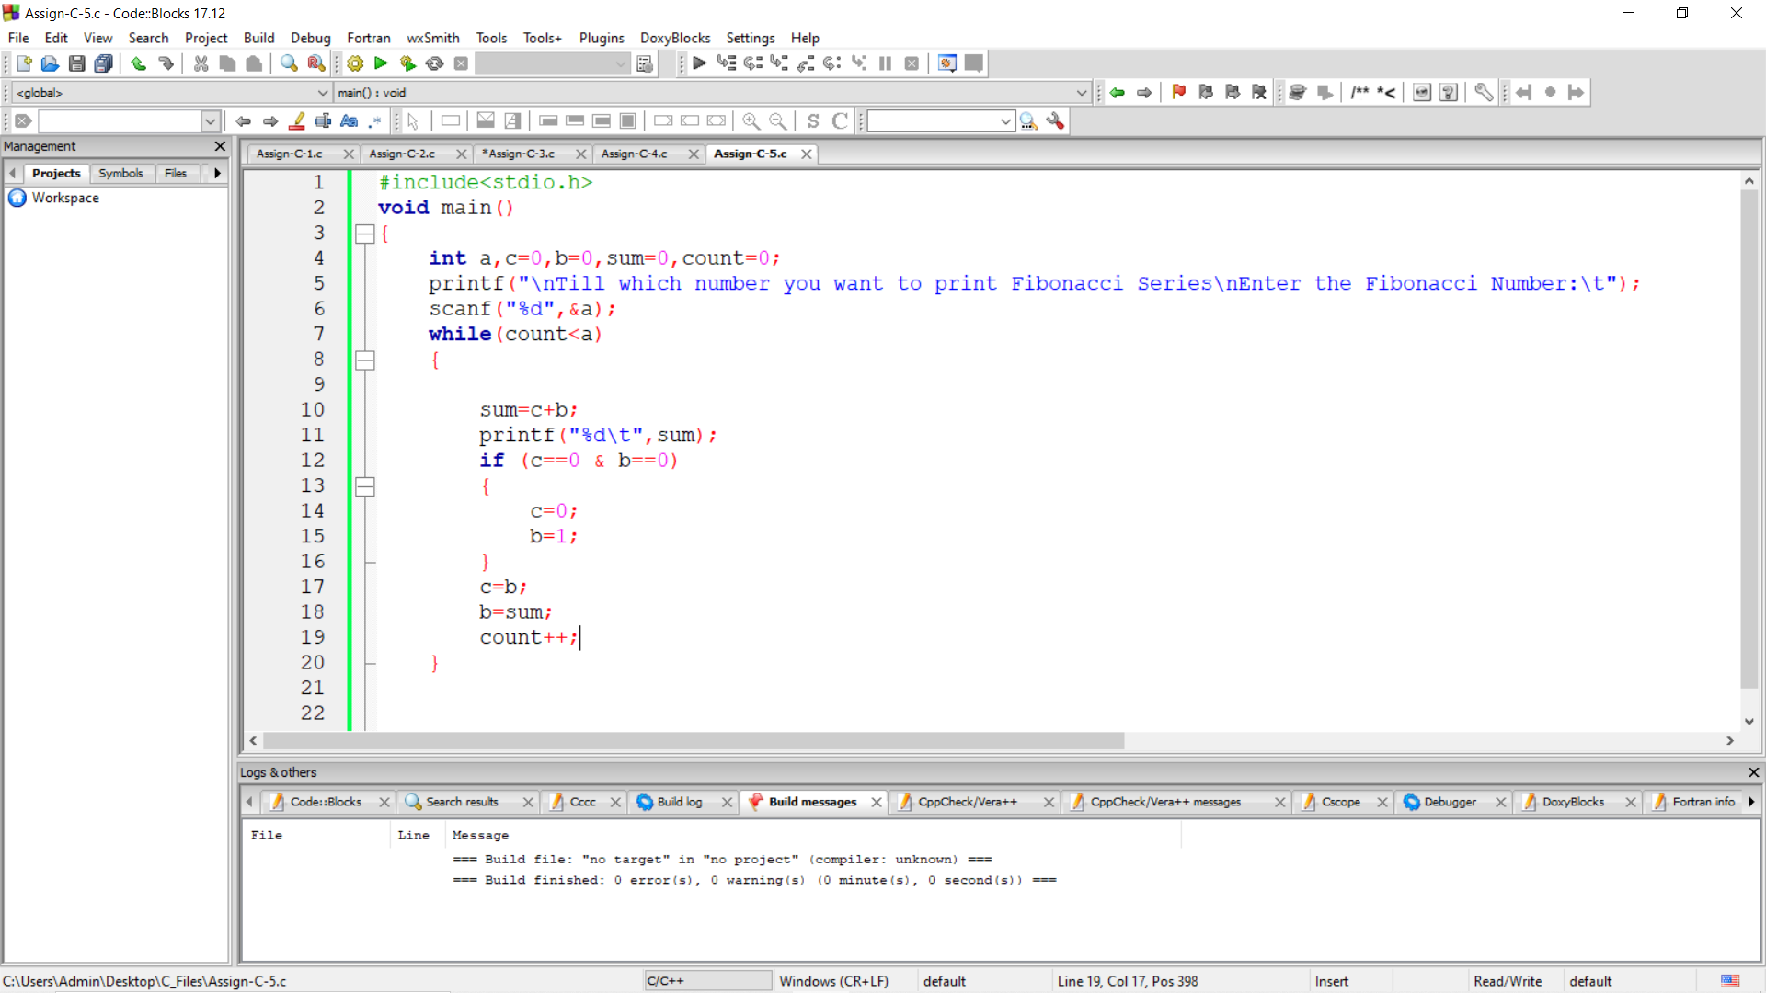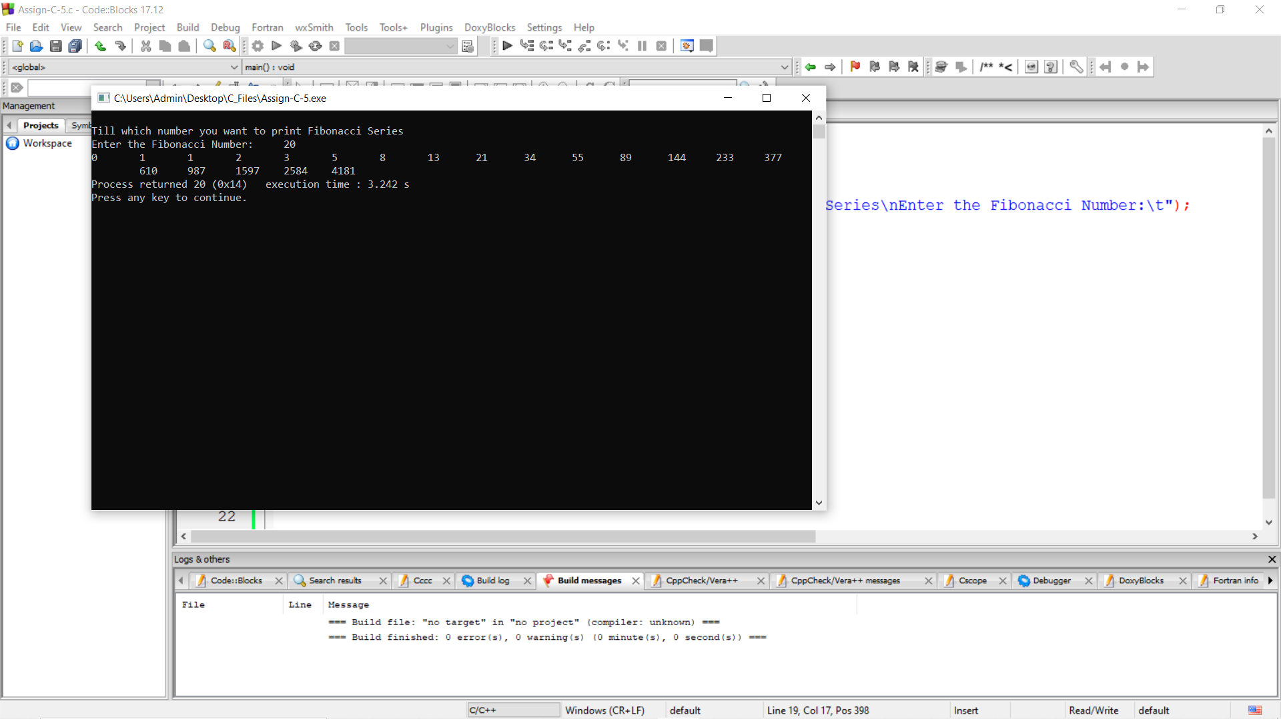

6) Write a C program to print a pyramid of stars.

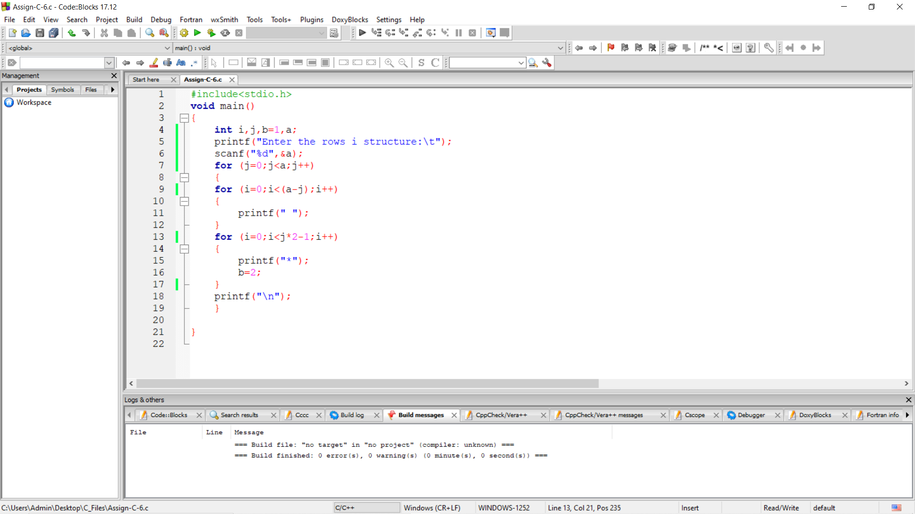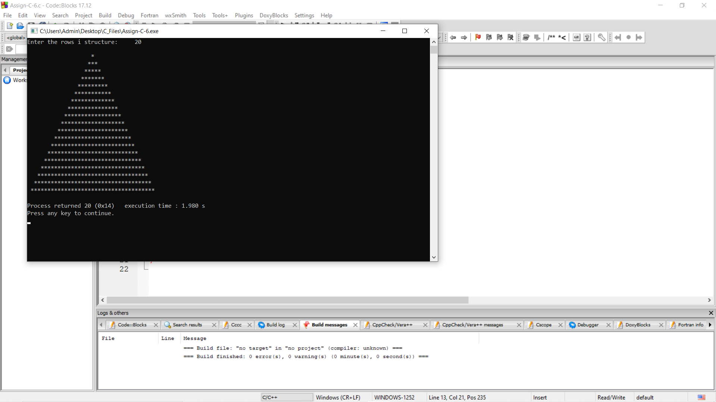

7) Write a C program to find if the entered number is a palindrome

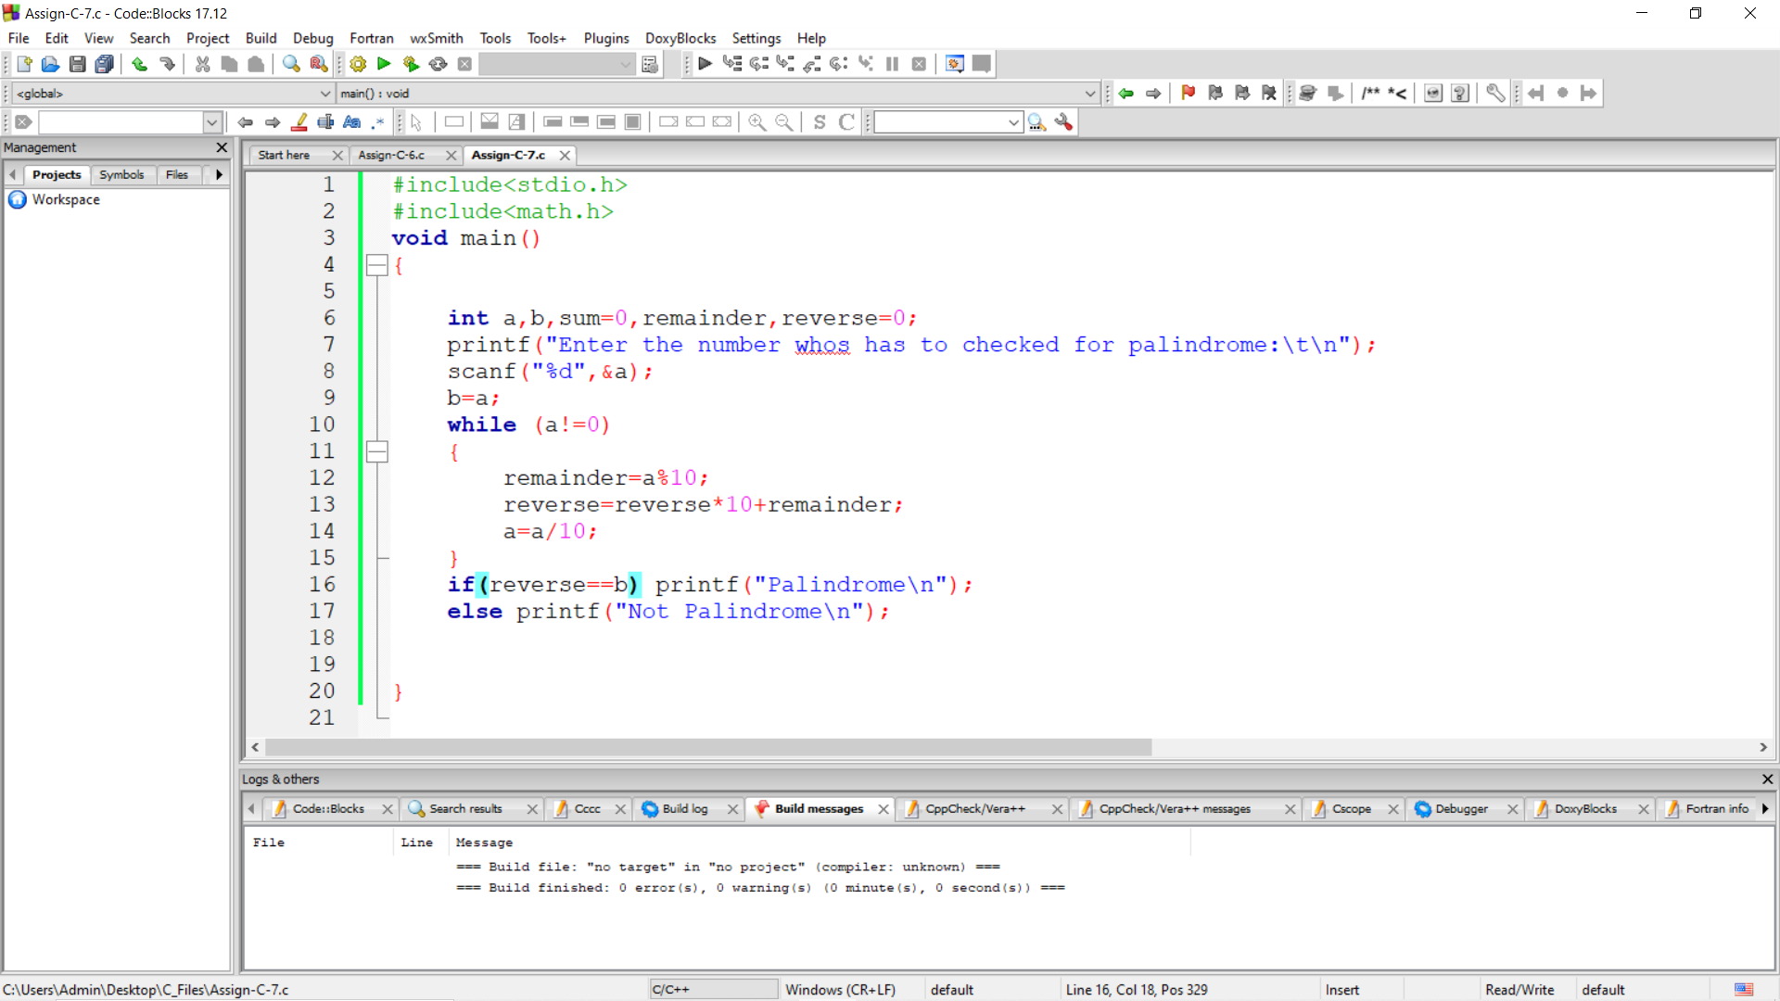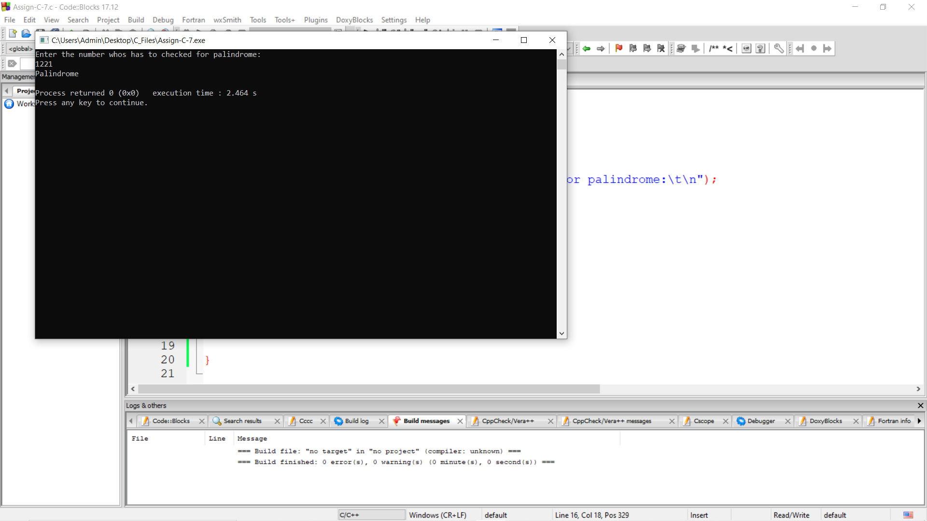

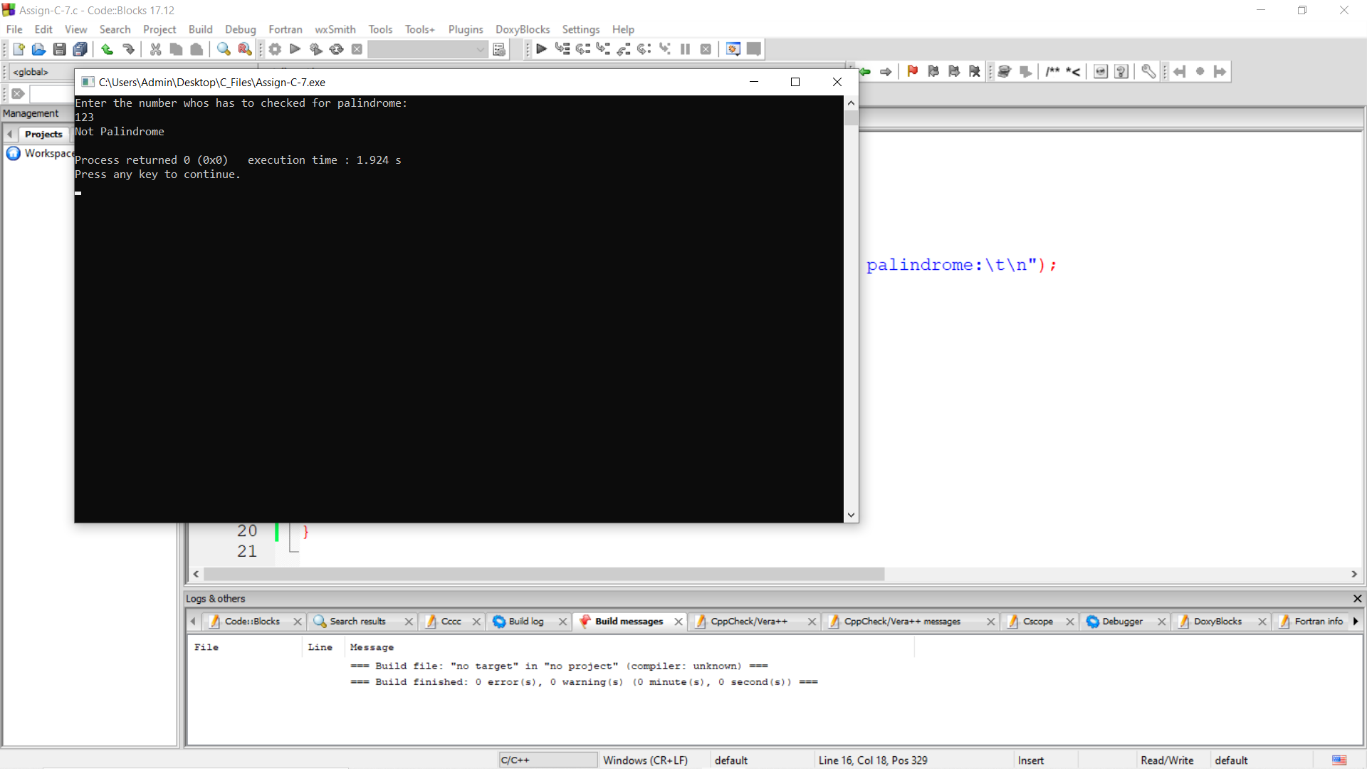

8) Write a C program to find the sum of digits of the entered number. (n=123 , sum=1+2+3=6)

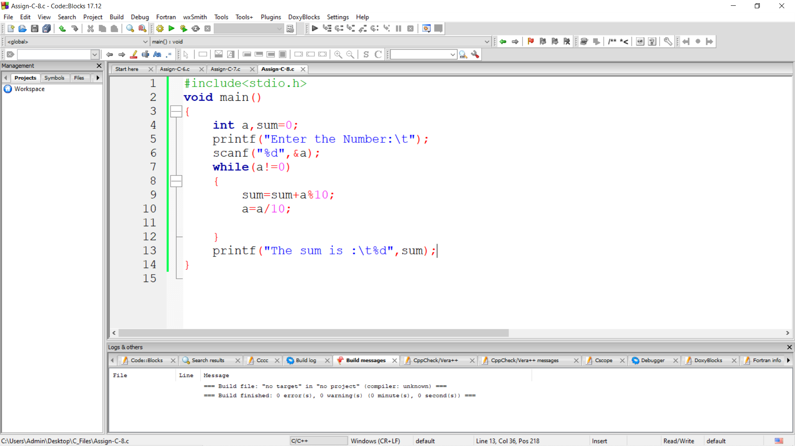

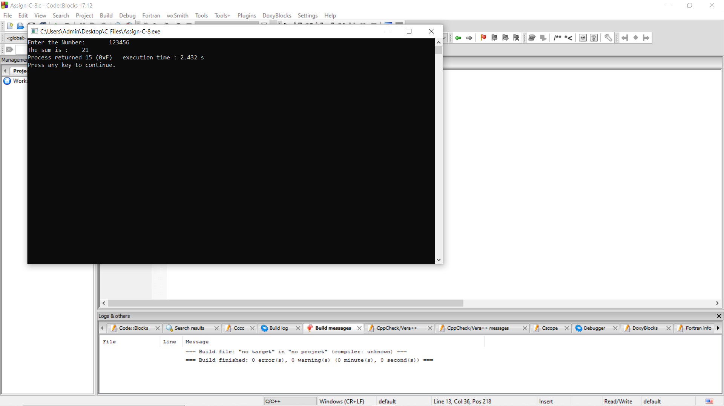

9) Write a C program to print the factorial of a number

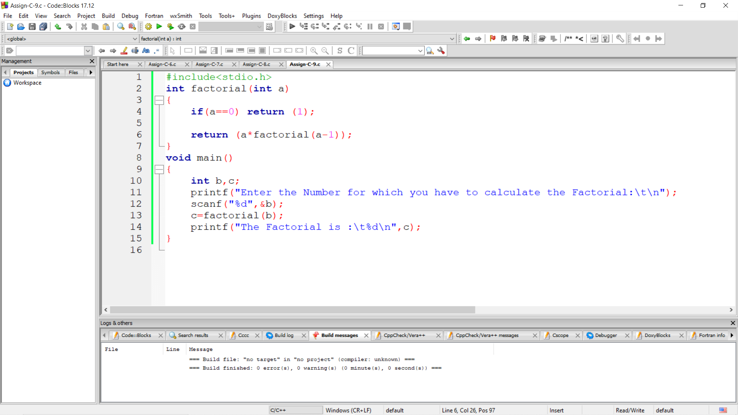

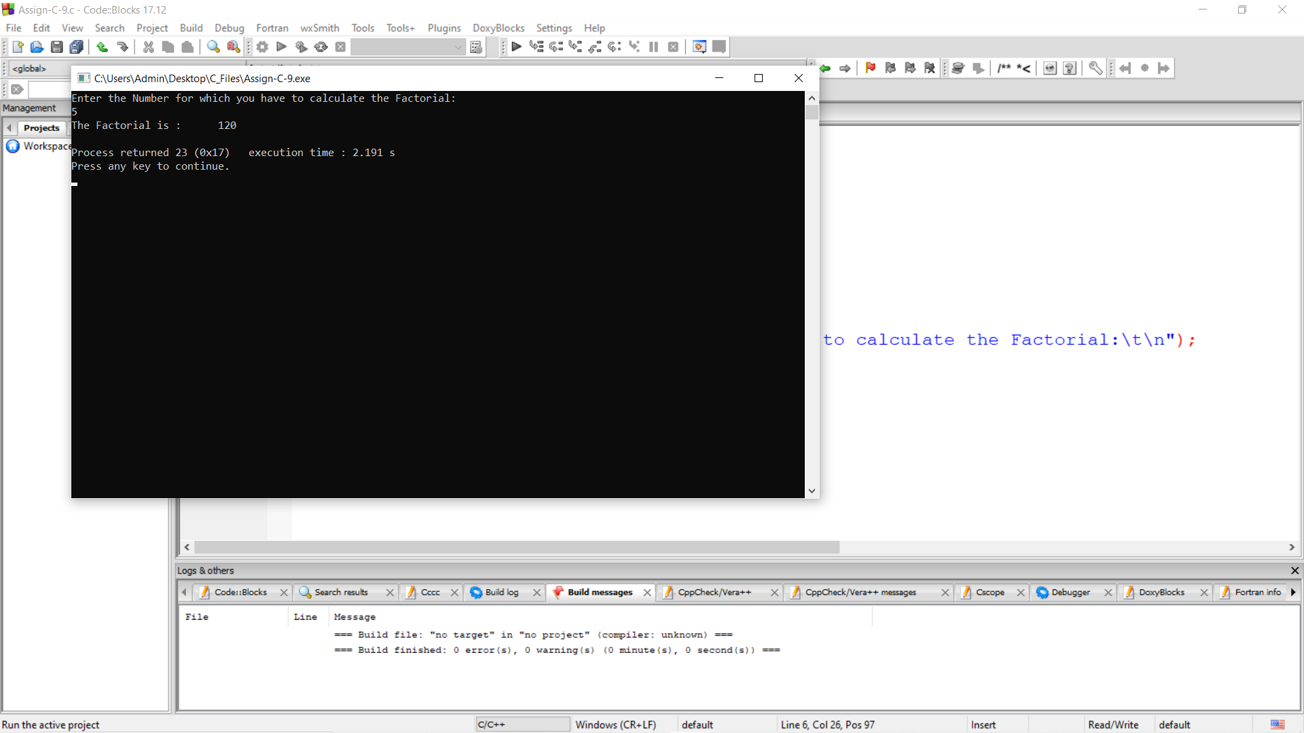

10) Write a C Program to print the sum of cube of digits of a number (n=123, sum = 1+4+9 = 14)

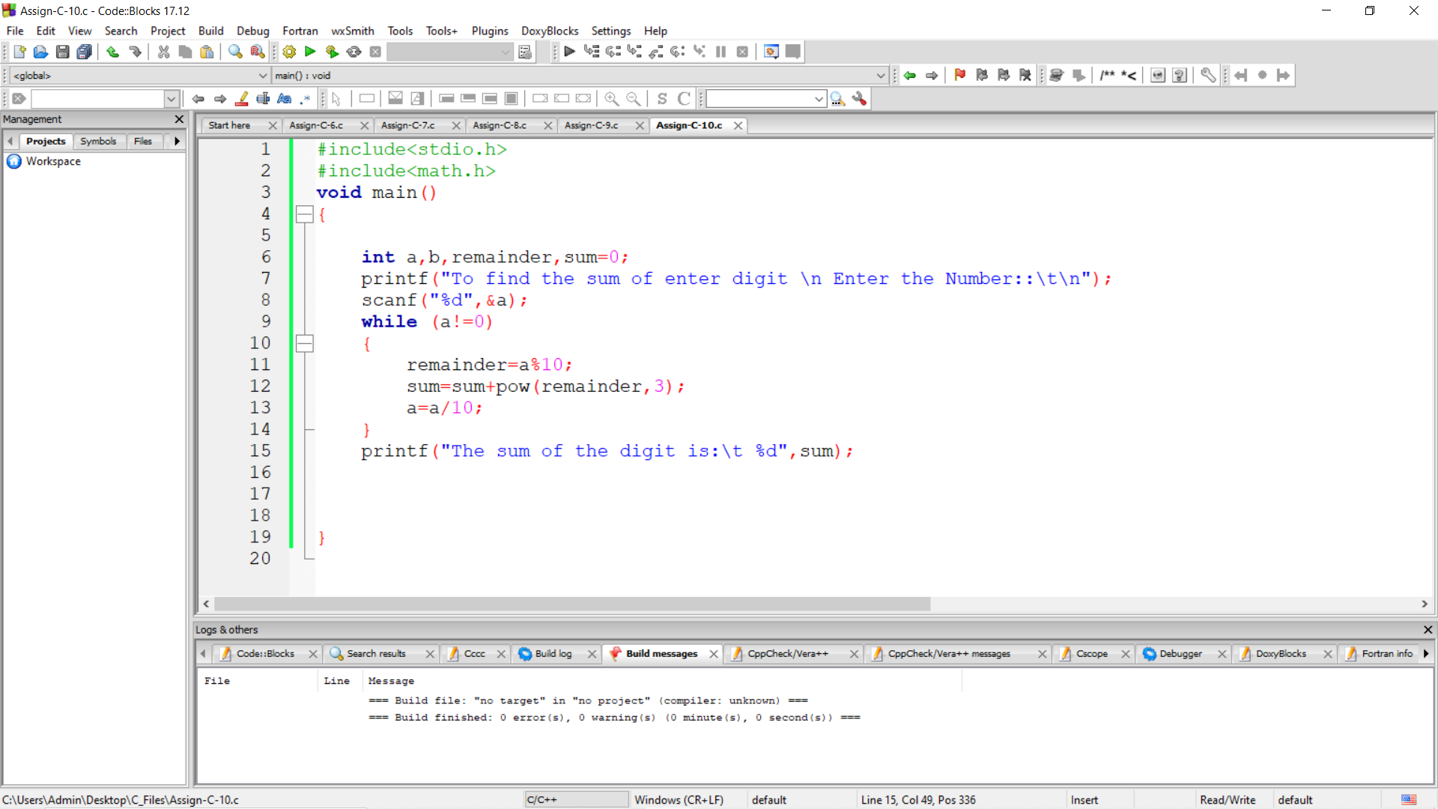

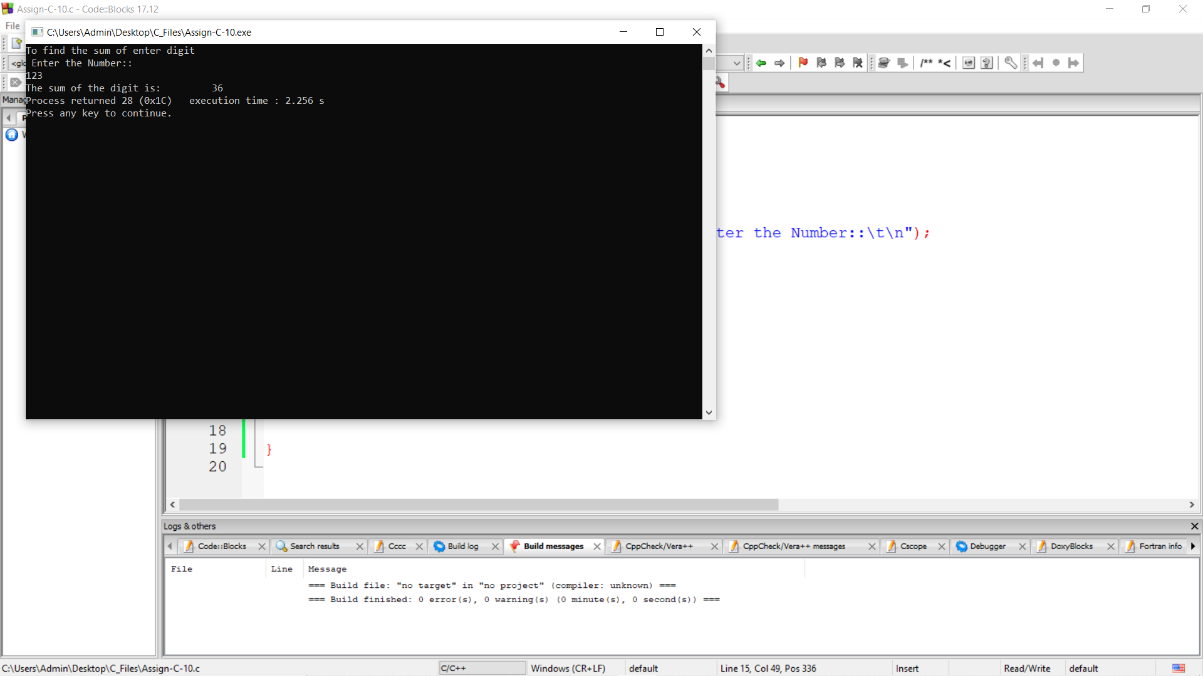

11) Write a program that reads number until a negative number is read and prints the number of values read, the largest values, smallest value and the range

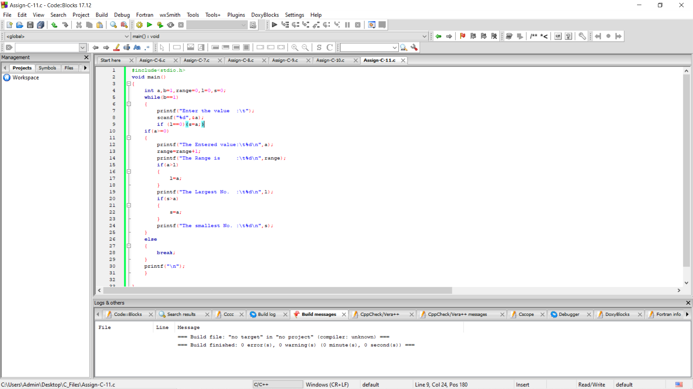

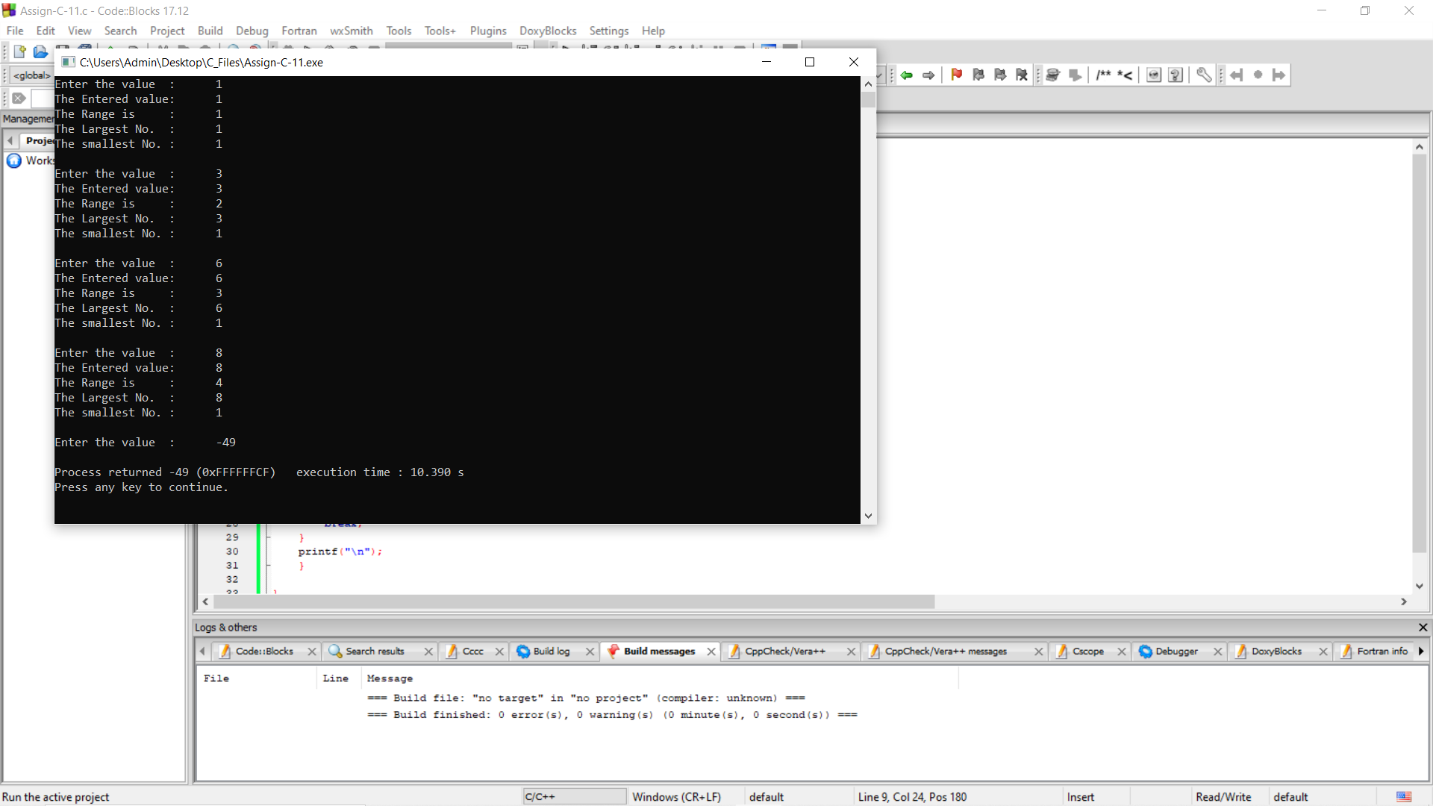

12) A perfect square is an integer which is the square of another integer. Write a program that reads a number and computes the first perfect square larger than this number.

